Bingo Code Implementation-Project Report
1. Cover Page
PROJECT REPORT: BINGO Game Implementation
DEVELOPER: Abinaya K
DATE OF SUBMISSION: September 29,2026
REPOSITORY LINK: https://github.com/abinaya26mib10081-cpu/vityarthi-project.git
2. Introduction
This report details the implementation of a terminal-based BINGO game written in Python. The application provides an interactive experience where a human user competes against a computer opponent to complete lines on a randomized number grid.
3. Problem Statement
The goal is to engineer a functional BINGO simulation utilizing a standard 5x5 grid format. The system must handle random number generation, maintain separate game states for the player and computer, evaluate standard bingo win conditions, and regulate turn-based gameplay natively within a command-line interface.

4. Functional Requirements
- The system must generate independent 5x5 matrices populated with randomized, unique integers ranging from 1 to 25 for both participants.

- The game must operate in a continuous loop, alternating turns between the player and the automated computer.

- During the player's turn, the system must accept an integer input between 1 and 25.

- The system must validate all inputs, rejecting numbers outside the 1-25 range and numbers that have already been played.

- During the computer's turn, the system must automatically select a random integer exclusively from the remaining pool of uncalled numbers.

- The application must detect completed rows, columns, and diagonals, progressively revealing the letters B-I-N-G-O for each achieved line.

- The game must terminate immediately and declare the respective winner once either the player or the computer successfully completes 5 lines.

5. Non-functional Requirements
- Usability: The command-line display must clearly render both grids and visually distinguish marked numbers by replacing them with an "X".

- Reliability: The application must not crash upon receiving valid integer inputs and must accurately log game history in the called_numbers list to prevent duplicate plays.
6. System Architecture
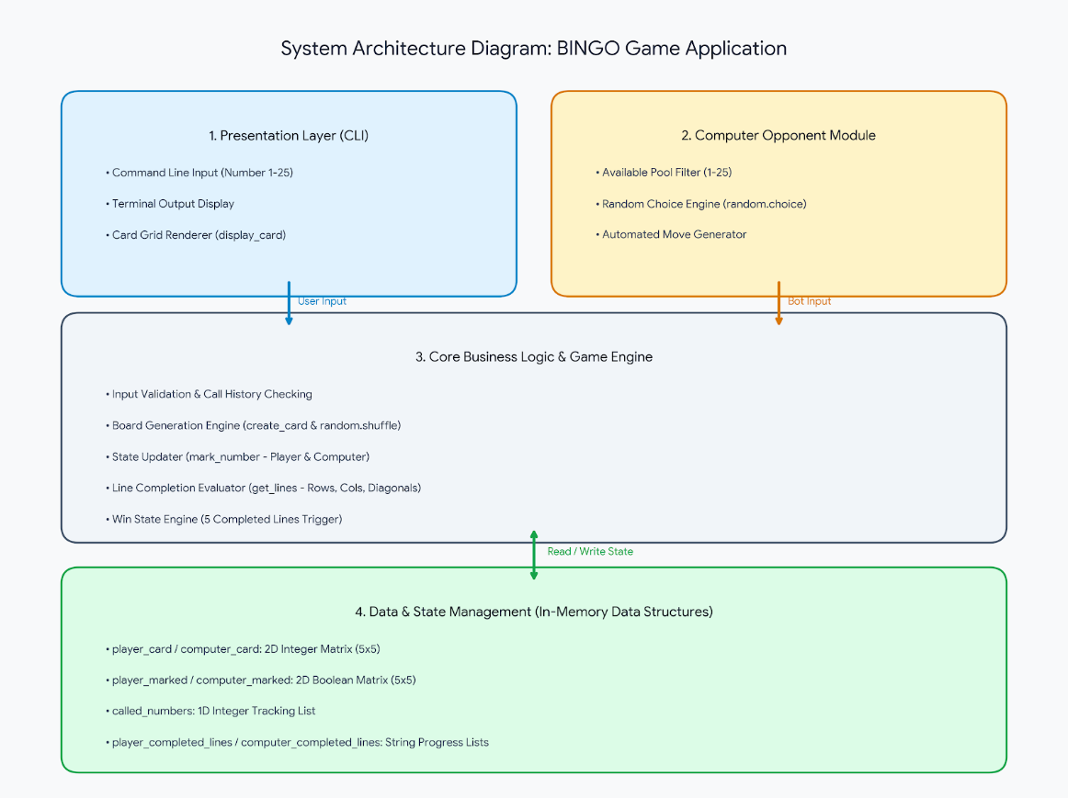

7. Design Diagrams

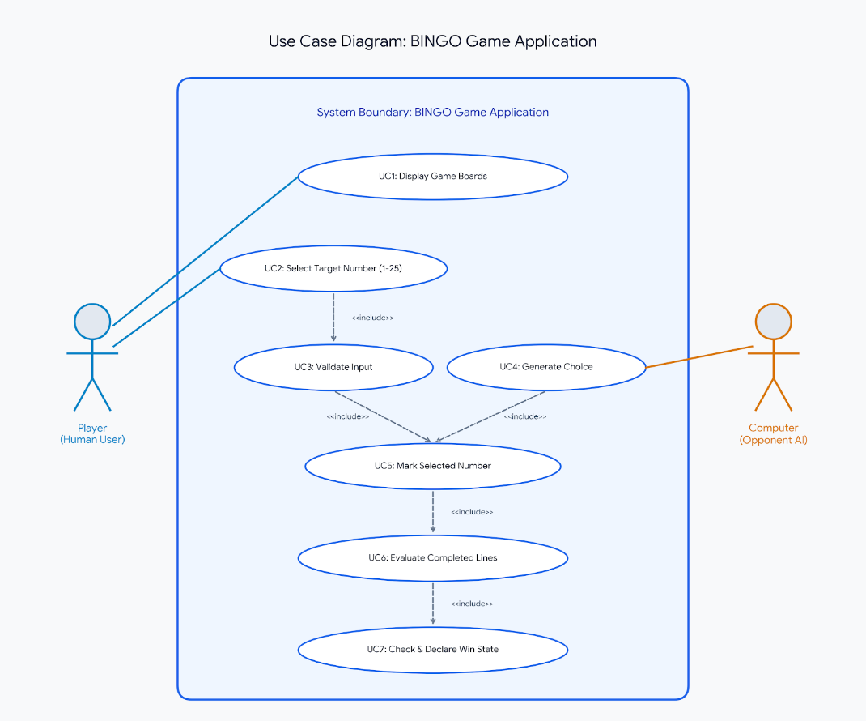
- Use Case Diagram:

- Workflow Diagram:
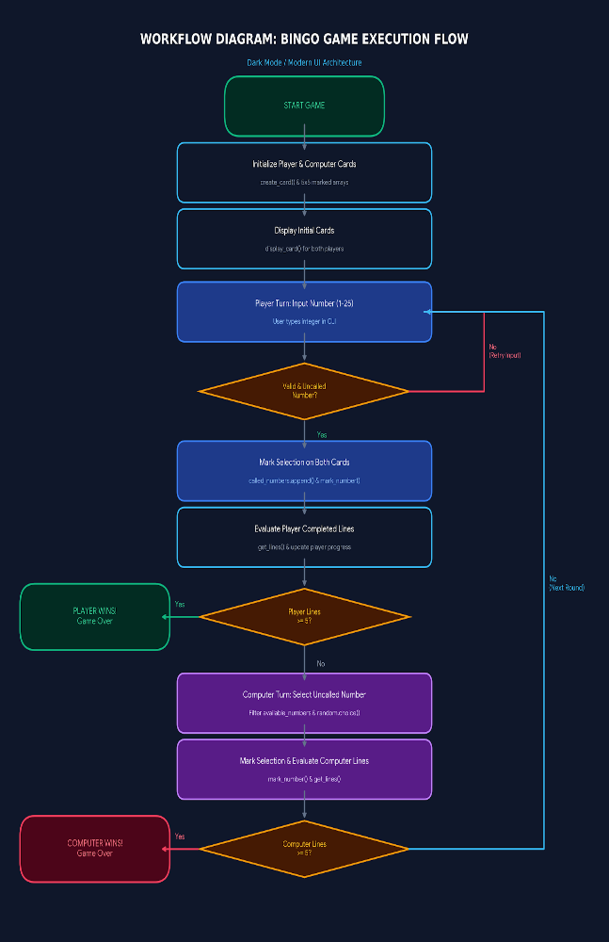

- Sequence Diagram:
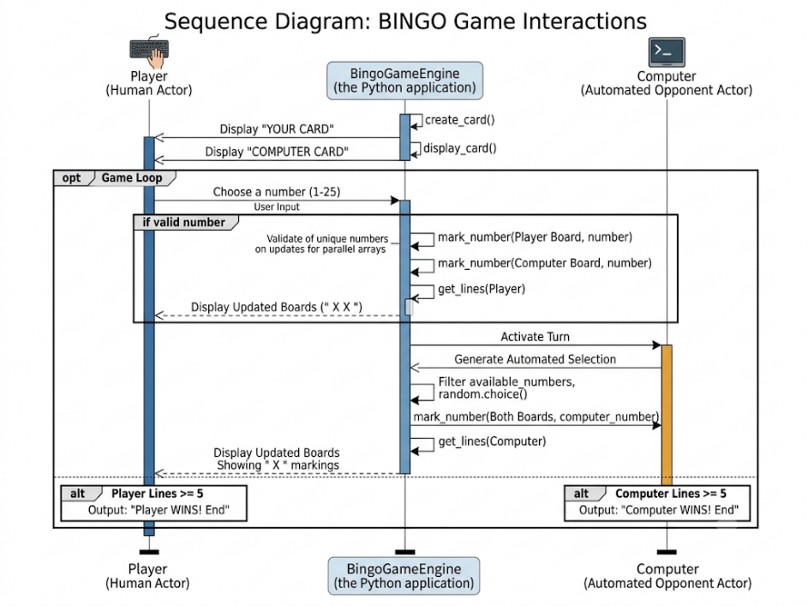
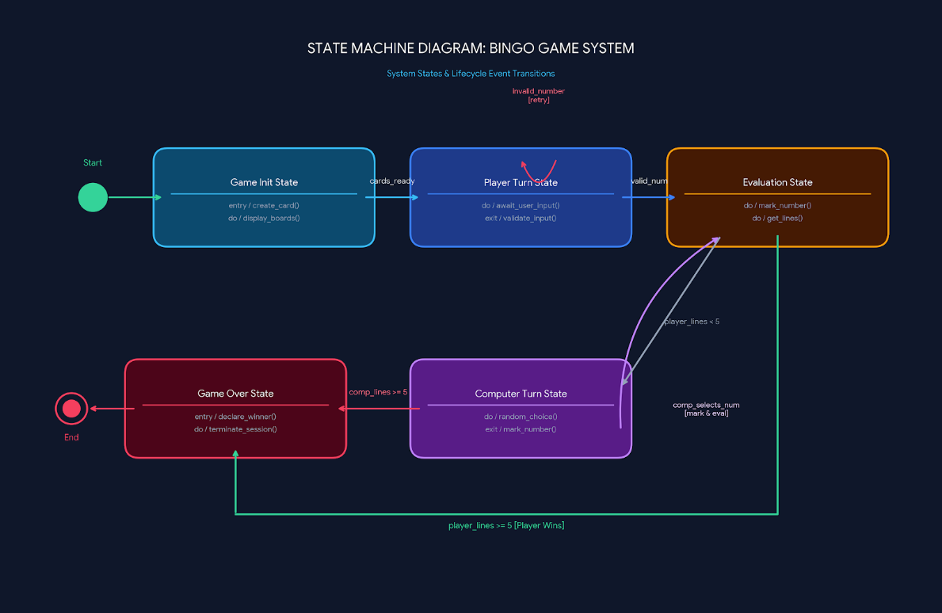
- Class/Component Diagram:

- ER Diagram:
Not applicable, as there is no database integration or persistent file storage utilized.

8. Design Decisions & Rationale

- Separation of State and Presentation: The numerical values (card) and their marked status (marked) are stored in parallel 2D lists. This design ensures the original numerical grid is preserved for logic checks, while making it trivial to render an " X " during the display_card() loop.

- Procedural Design: Object-oriented programming overhead was intentionally avoided. The use of pure functions mapping to global arrays keeps the game loop simple, fast, and easy to debug.

9. Implementation Details

- Language & Core Libraries: Developed strictly in Python, utilizing the native random module.

- Board Generation: The create_card() method initializes a linear list from 1 to 25, applies random.shuffle(), and chunks the sequence into a 5x5 multidimensional array.

- Win Detection Mathematics: The get_lines() function utilizes boolean flags to scan arrays. It checks horizontals (marked[i][j]), verticals (marked[i][j] transposed), and specific diagonal index patterns (marked[i][i] for descending and marked[i][4 - i] for ascending diagonals).

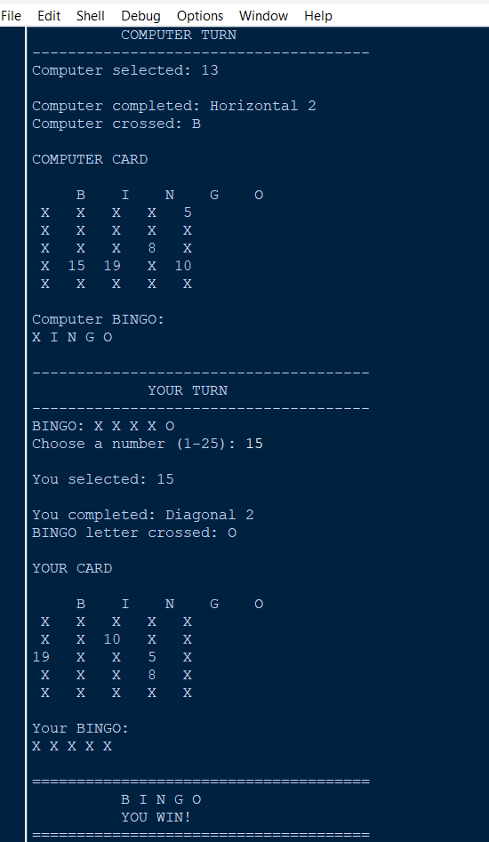
10. Screenshots / Results
11. Testing Approach
Quality assurance is built directly into the main loop via conditional validation.

- Boundary testing is applied to user input; integers $<1$ or $>25$ trigger a localized continue statement and prompt the user to try again.

- Duplicate entry testing ensures that inputs existing in the called_numbers list are rejected before the board is altered.

12. Challenges Faced

- Algorithmic Computer Turns: Ensuring the computer does not waste turns required dynamically generating an available_numbers list on every loop iteration by filtering out elements already present in called_numbers.

- Index-Safe Output: Mapping completed line counts directly to the letters in ["B", "I", "N", "G", "O"] required precise length tracking (bingo_letters[len(player_completed_lines) - 1]) to prevent out-of-bounds exceptions when iterating over the current progress display.

13. Learnings & Key Takeaways
This implementation successfully highlights the utility of multi-dimensional arrays in spatial grid simulations. It demonstrates how efficiently Python can handle game loops, matrix traversal, and automated opponent logic without requiring external dependencies or heavy graphical libraries.

14. Future Enhancements
- Integration of a Graphical User Interface (GUI) via libraries like Tkinter to replace the command-line rendering.

- Implementation of distinct difficulty levels for the computer (e.g., an AI that attempts to prioritize specific numbers to complete its own grid faster).

- Configurable grid dimensions and customized win rules (like corner-only BINGO).

15. References
- Codebase: ABINAYA 26MIB10081_2.py

